Gymea Bay Cricket Club
Net Expansion Proposal
Extract

Summary
Gymea Bay Cricket Club (GBCC) is in the position of being a Club that is growing in membership and reputation. This success is due, in no small part, to the efforts of all of the members of the Club who seek to ensure that the Club provides a positive environment for players and families. Over the last few seasons our members have contributed significant time and effort to raise funds, these efforts have resulted in raising approximately $100,000 to support club activities.
Investigations were undertaken to identify and examine options to invest these funds in a manner that provides long term benefits to the club and its members while also contributing to the local community and not imposing an undue burden on Club volunteers and funding to maintain. In addition the question used to check the options was “what is the best use for Club funds at the current time?”
Considerations in developing the options for investing in new facilities include:
- Facilities need to encompass traditional cricket net training and ability to conduct skill based activities
- Cricket training equipment storage area is needed regardless of option selected
  - Bowling machine net required including power supply relocation
- Space for new facilities at Gymea Bay Oval is limited
  - Compensate for limited oval use availability during dominant sport activities
- Improved access and security design
  - Reduced demand for volunteers to issue / attend site with keys
- Safety considerations
  - Players – various age groups sharing nets at same time, multiple nets in use
  - Other users of Gymea Bay oval - particularly in preseason training
- New facilities needed at Gymea Bay Oval to meet increasing demands
  - Cricket Club
  - SSJCA & SSCA
  - Other sporting groups (potentially)
- Local resident ongoing issues with existing facilities, which would lead to likely opposition for expansion to existing nets. Improved security and access control would assist addressing these concerns
- Additional funding is likely to be required to build a suitable facility that is secure and meets ongoing Club needs and higher probability of obtaining funding if facility being developed has multi use / purpose capability
After consideration of alternatives outlined in the Gymea Bay Club Nets Proposal tabled to members in January 2016, the expansion of existing net facility in Lot 2 with improved safety and multi-use capabilities was selected as the preferred option.
This was agreed following SSC indication that joint development on Gymea Bay Oval Netball courts was “unlikely” to receive council support.

This option is identified on the following aerial view of Gymea Bay Oval.
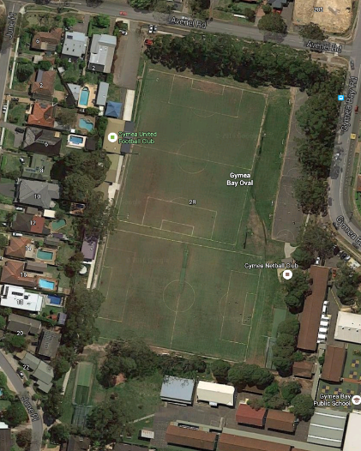

Financials
Indicative figures based on a preliminary quote from Gabba Sports indicates a cost in the vicinity of $185,000 - $200,000 for a “greenfield” multi-purpose project dependent on scope and inclusions.
It is anticipated that existing infrastructure, can be reused to reduce the final project cost.
Competitive quotes are to be sourced (Minimum 3) to ensure value and cost effectiveness of the proposed facility development.

Appendix 1 Facility Development Details
Expansion and reconfiguration of the existing cricket net facilities to a fully enclosed arrangement.
New layout to encompass the existing cricket nets with the addition of 2 new practice nets and a storage area including soft form pitch separation netting and a permanent netting ceiling to contain activities within the enclosed area.
This option also includes consideration for providing the capability for other sports to use the facility when not in cricket training setup.

Works required
- Expansion of slab
- Artificial turf installation, ideally with rubber underlay at bowling crease end to assist with injury prevention
- Standard (rigid) steel mesh fencing surrounds to height of 4m (13.1 feet)
[Cricket Australia suggested 3m – 4m]
- Nylon “ceiling” netting 1 metre on edges (taking total net height to 5 m – 16.4ft) and covering across total enclosed area to prevent balls leaving net area
- Fencing between gated entry and storage area including practice area “entry run” creation
- Provision of storage shed (within enclosed area) for training equipment and supplies (ball machine, rebound stumps (to eliminate need to have stump holes in surface), training balls etc.
- Power supply for bowling machine (Relocate from adjacent to Scout hall)
- Pin coded security lock on gates to minimise need for issuing keys to facility and requirement for Club volunteer attendance to open and close facility
Considerations
- Provides facility which can be used safely for multiple activities through ease of reconfiguration of the facility by simply storing the movable separation nets allowing for ground based fielding and training drills and other activities
- Addresses Current issue with safety when Cricket practice is being conducted whilst other activities are underway on oval
- Costings based on to net proposal
- Pre-marking of surface for cricket and other sport use layouts
Design Outlines
Preliminary design diagrams are contained in following pages

Design Outlines:
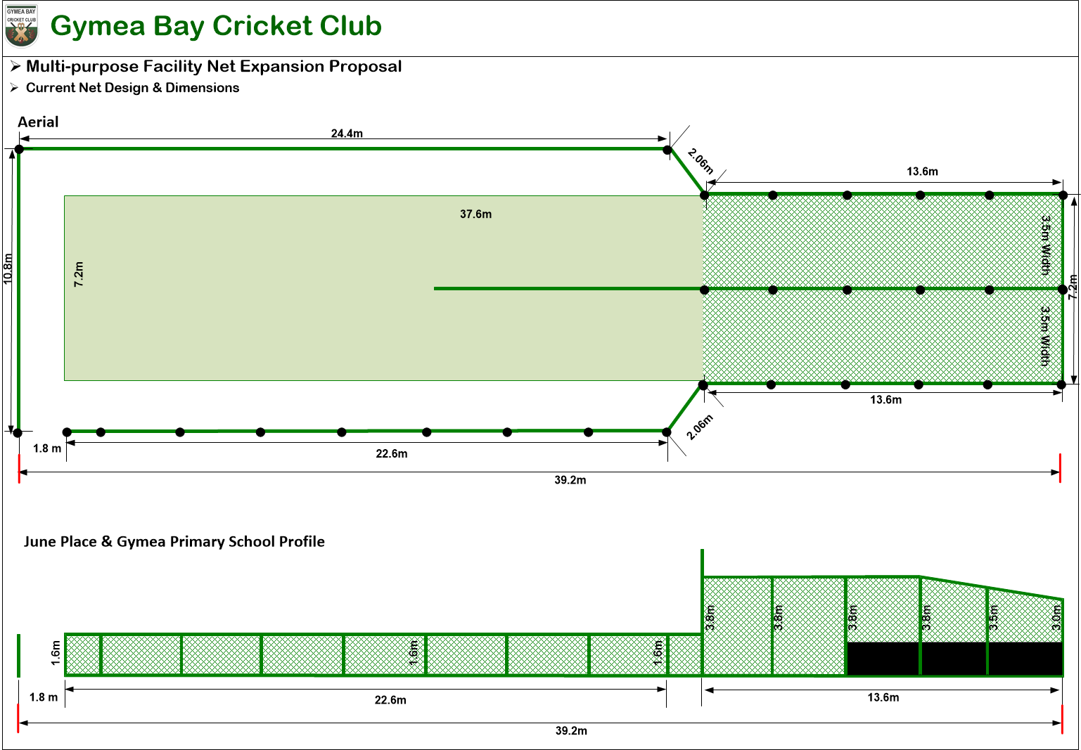

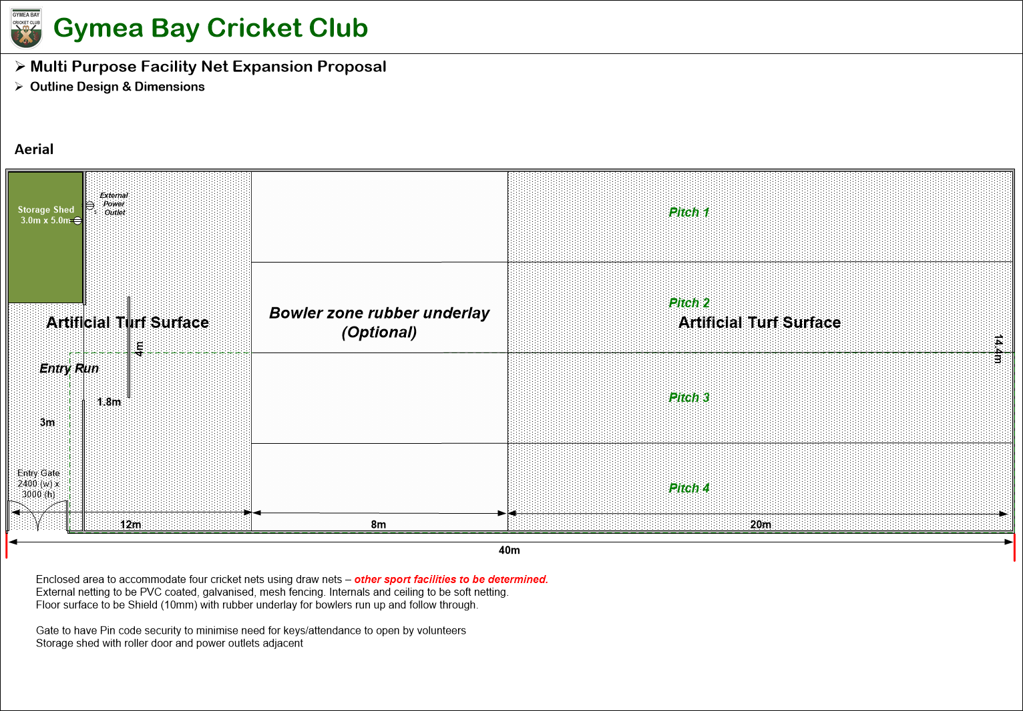

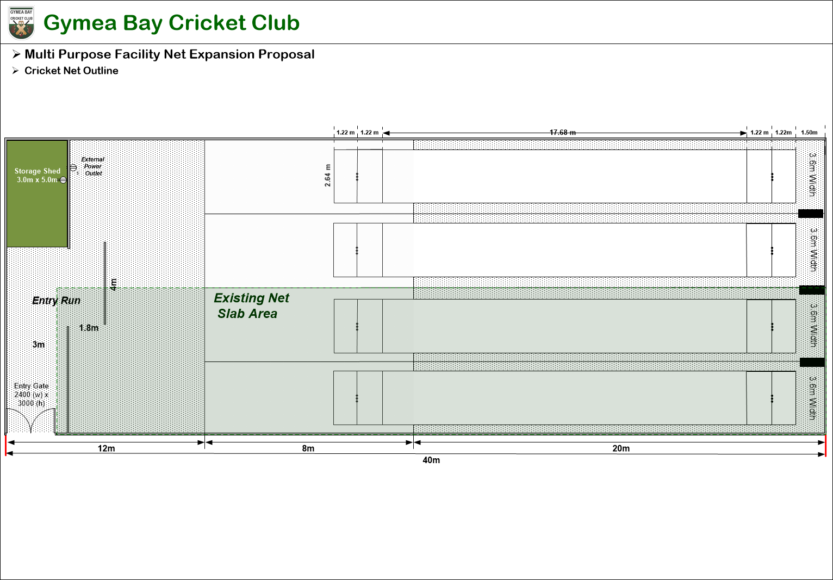
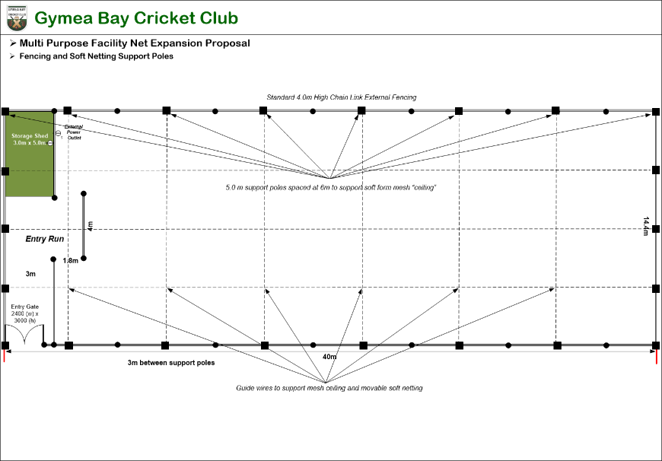

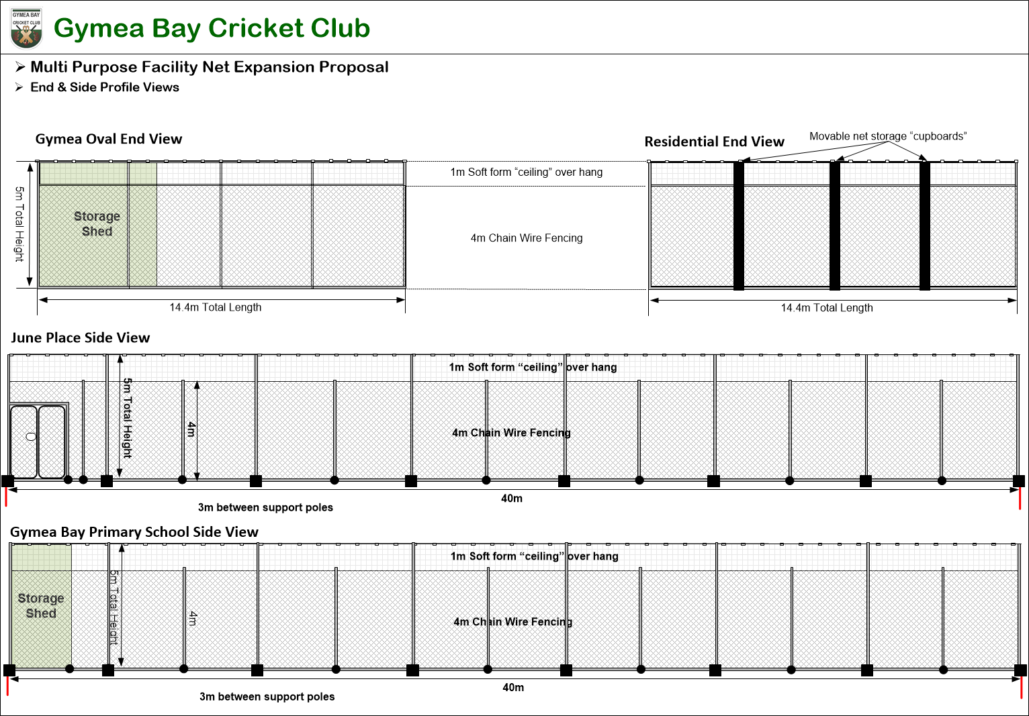
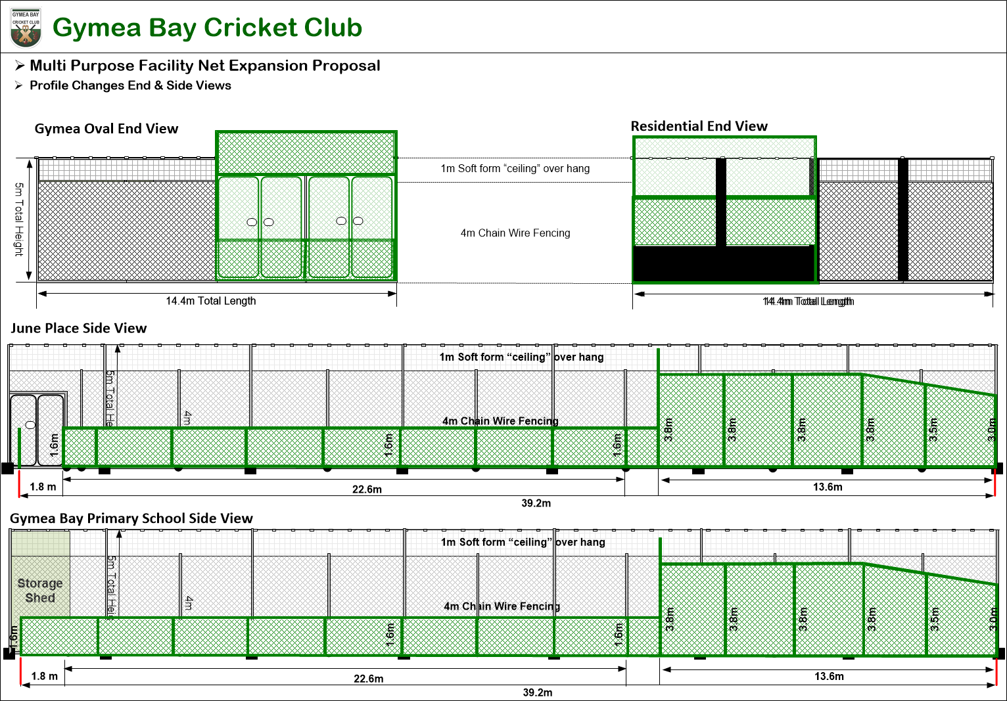

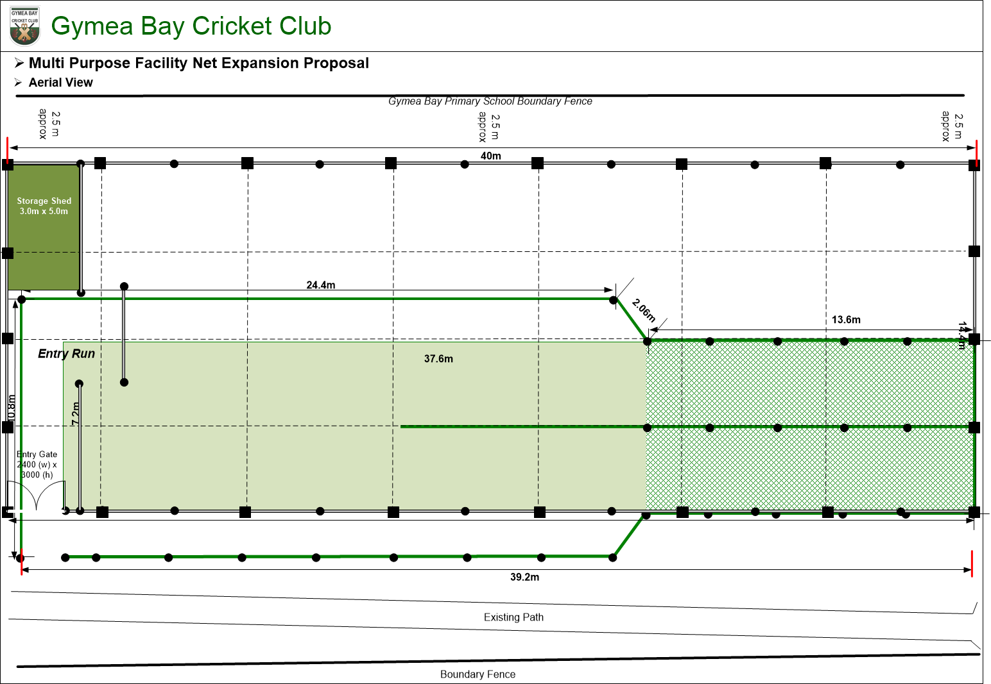

Some sample images providing an illustration of the facility proposed follow.
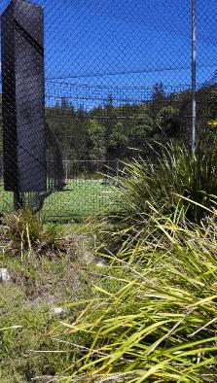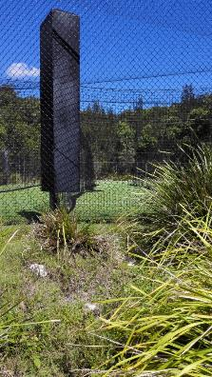

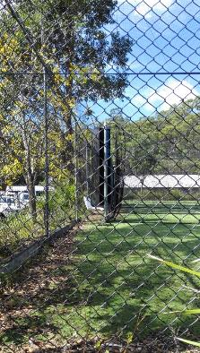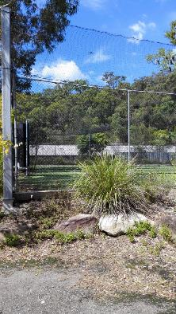

Similar style installation at State Sports & Recreation Centre Narrabeen

NOTES:

